**Q1**

1(a)

Here, as we do not have a specific learning rate requirement, we use learning_rate_schedule_exponential_decay() and set initial_learning_rate to 0.001. Then consider following different filter numbers.

From the above results, it is observed that filter sequences c(16, 32, 64, 128, 256)exhibit superior performance with an accuracy of 0.9423. Moving on to 1(b), we also consider filter sequences c(8, 16, 32) and c(16, 32, 64, 128) , c(16, 32, 64, 128, 256, 512)

|  |
| --- |
|  |

|  |  |  |  |  |  |
| --- | --- | --- | --- | --- | --- |
| lr_initial | filter | val_loss | val_acc | test_loss | test_acc |
| 0.001 | c(8, 16) | 0.6914 | 0.5778 | 0.6914 | 0.5774 |
| 0.001 | c(16, 32) | 0.5957 | 0.7242 | 0.5840 | 0.7480 |
| 0.001 | c(8, 16, 32) | 0.3534 | 0.8980 | 0.3405 | 0.9134 |
| 0.001 | c(16, 32, 64) | 0.6455 | 0.5784 | 0.6467 | 0.5774 |
| 0.001 | c(8, 16, 32, 64) | 0.6771 | 0.5778 | 0.6771 | 0.5774 |
| 0.001 | c(16, 32, 64, 128) | 0.3696 | 0.9032 | 0.3588 | 0.9081 |
| 0.001 | c(16, 32, 64, 128, 256) | 0.3342 | 0.9265 | 0.3100 | 0.9423 |
| 0.001 | c(32, 64, 128, 256, 512) | 0.5700 | 0.5778 | 0.5663 | 0.5774 |
| 0.001 | c(16, 32, 64, 128, 256, 512) | 0.3927 | 0.8653 | 0.3877 | 0.8556 |

as they demonstrate commendable accuracy. The following loss vs accuracy plot corresponding to model with filter sequences c(16, 32, 64, 128, 256). There not exist overfit and the learning rate is not high or low situation.

### 

1(b)

|  |  |  |  |  |  |  |
| --- | --- | --- | --- | --- | --- | --- |
| lr_initial | filter | rotation | val_loss | val_acc | test_loss | test_acc |
| 0.001 | c(8, 16, 32) | TRUE | 0.6605 | 0.5778 | 0.6628 | 0.5774 |
| 0.001 | c(16, 32, 64, 128) | TRUE | 0.6742 | 0.5778 | 0.6746 | 0.5774 |
| 0.001 | c(16, 32, 64, 128, 256) | TRUE | 0.6745 | 0.5778 | 0.6746 | 0.5774 |
| 0.001 | c(16, 32, 64, 128, 256, 512) | TRUE | 0.5519 | 0.7860 | 0.5365 | 0.7822 |

Rotation and flipping do not improve the performance.

|  |  |  |  |  |  |  |
| --- | --- | --- | --- | --- | --- | --- |
| lr_initial | filter | flipping | loss | val_acc | test_loss | test_acc |
| 0.001 | c(8, 16, 32) | TRUE | 0.6916 | 0.5778 | 0.6916 | 0.5774 |
| 0.001 | c(16, 32, 64, 128) | TRUE | 0.6352 | 0.5778 | 0.6334 | 0.5774 |
| 0.001 | c(16, 32, 64, 128, 256) | TRUE | 0.6622 | 0.5778 | 0.6630 | 0.5774 |
| 0.001 | c(16, 32, 64, 128, 256, 512) | TRUE | 0.6746 | 0.5778 | 0.6754 | 0.5774 |

1(c)

|  |  |  |  |  |  |  |
| --- | --- | --- | --- | --- | --- | --- |
| lr_initial | filter |  | val_loss | val_acc | test_loss | test_acc |
| 0.001 | c(16, 32, 64, 128, 256) | batch_norm | 0.0948 | 0.9889 | 0.0868 | 0.9948 |
| 0.001 | c(16, 32, 64, 128, 256, 512) | batch_norm | 0.0497 | 0.9918 | 0.0421 | 0.9948 |
| 0.001 | c(16, 32, 64, 128, 256) | sep_conv | 0.6810 | 0.5778 | 0.6811 | 0.5774 |
| 0.001 | c(16, 32, 64, 128, 256, 512) | sep_conv | 0.6810 | 0.5778 | 0.6811 | 0.5774 |
| 0.001 | c(16, 32, 64, 128, 256) | resid_con | 0.6693 | 0.5778 | 0.6692 | 0.5774 |
| 0.001 | c(16, 32, 64, 128, 256, 512) | resid_con | 0.6616 | 0.5778 | 0.6592 | 0.5774 |

Batch normalization significantly improves the model's performance. Following that, we identified the best model with the filter sequence c(16, 32, 64, 128, 256) and incorporated batch normalization into parts d and e.

**1(d)**

From the above result, choose a model with filter c(16,32), plus rotation to Provide a visualization of the interesting activation layers. The following figure is a summary of this model.

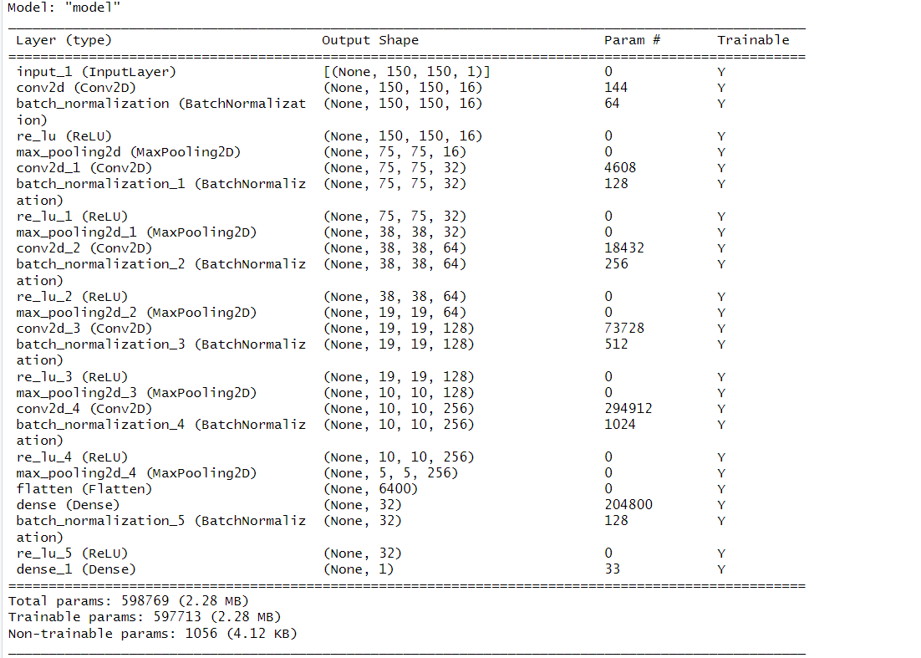

**Displaying the test picture:**



**Visualizing every channel in every intermediate activation:** **the features extracted by a layer become increasingly abstract with the depth of the layer. The activations of higher layers carry less and less information about the specific input being seen and more and more information about the target, which implies that our model is good.**

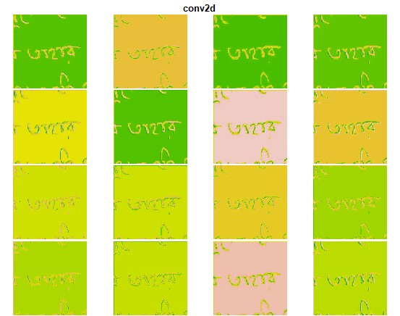

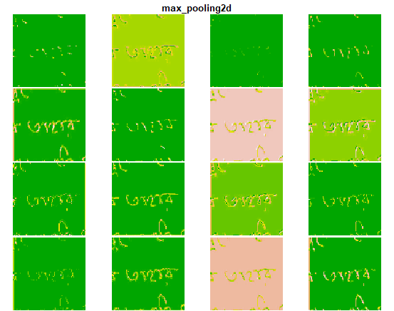

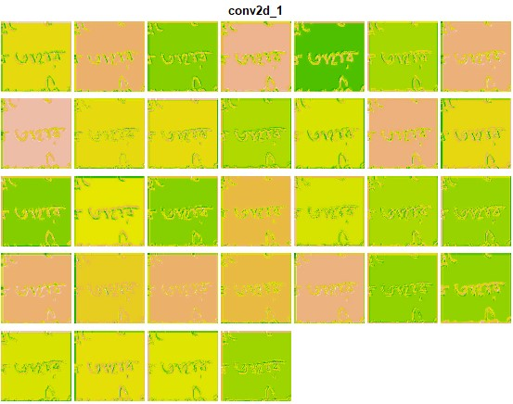

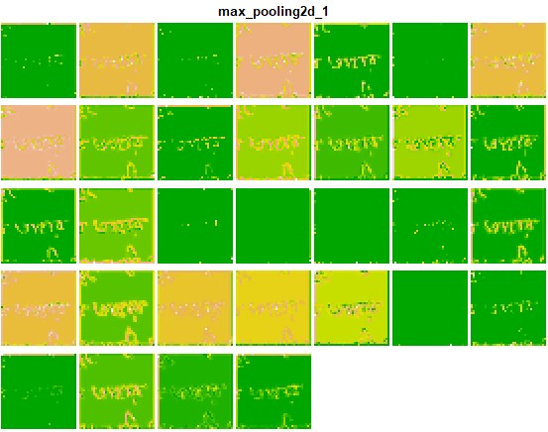

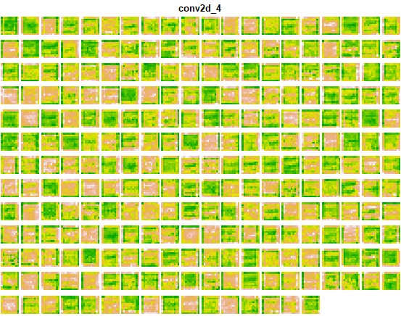

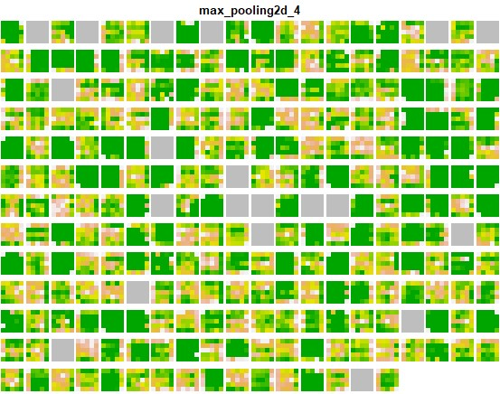

**1(e)**

**Visualizing Probability of Activations**

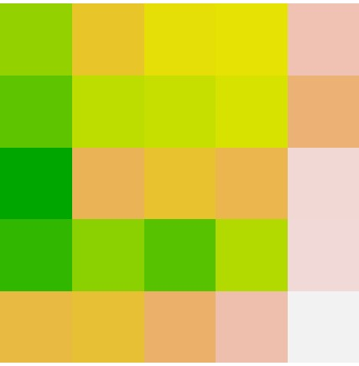

**Visualizing Activations with context**



**Q2**

**2(a)**

Here, as we do not have a specific learning rate requirement, we use learning_rate_schedule_exponential_decay() and set initial_learning_rate to 0.001. Then consider following different filter numbers.

|  |  |  |  |  |  |
| --- | --- | --- | --- | --- | --- |
| lr_initial | filter | val_loss | val_acc | test_loss | test_acc |
| 0.001 | c(8, 16) | 0.3078 | 0.8929 | 0.3195 | 0.8750 |
| 0.001 | c(16, 32) | 0.3207 | 0.9127 | 0.3075 | 0.9286 |
| 0.001 | c(8, 16, 32) | 0.3532 | 0.8770 | 0.3890 | 0.8214 |
| 0.001 | c(16, 32, 64) | 0.5048 | 0.8135 | 0.5017 | 0.8750 |
| 0.001 | c(8, 16, 32, 64) | 0.3330 | 0.8611 | 0.4089 | 0.8036 |
| 0.001 | c(16, 32, 64, 128) | 0.1675 | 0.9365 | 0.2483 | 0.9464 |
| 0.001 | c(32, 64, 128, 256) | 0.2123 | 0.9167 | 0.2645 | 0.9464 |
| 0.001 | c(8, 16, 32, 64, 128) | 0.2863 | 0.8929 | 0.3229 | 0.9107 |
| 0.001 | c(8, 16, 32, 64, 128, 256) | 0.2656 | 0.8929 | 0.3304 | 0.8929 |

From the above results, it is observed that filter sequences c(16, 32, 64, 128) and c(32, 64, 128, 256) exhibit su**perior per**formance with an accuracy of 0.9464. Moving on to 2(b), we also consider filter sequences c(16, 32) and c(8, 16, 32, 64, 128) as they demonstrate commendable accuracy.

**2(b)**

|  |  |  |  |  |  |  |
| --- | --- | --- | --- | --- | --- | --- |
| lr_initial | filter | rotation | val_loss | val_acc | test_loss | test_acc |
| 0.001 | c(16, 32) | T | 0.2531 | 0.9286 | 0.2007 | 0.9643 |
| 0.001 | c(16, 32, 64, 128) | T | 0.3518 | 0.8810 | 0.2991 | 0.9107 |
| 0.001 | c(32, 64, 128, 256) | T | 0.4650 | 0.8571 | 0.4813 | 0.8214 |
| 0.001 | c(8, 16, 32, 64, 128) | T | 0.2729 | 0.9286 | 0.2159 | 0.9643 |

Here, factor = 0.2 for the rotation parameter. And rotation improve the performance for model with filter sequence c(16, 32) and c(8, 16, 32, 64, 128).

|  |  |  |  |  |  |  |
| --- | --- | --- | --- | --- | --- | --- |
| lr_initial | filter | flipping | val_loss | val_acc | test_los | test_ac |
| 0.001 | c(16, 32) | T | 0.3506 | 0.8452 | 0.5536 | 0.7143 |
| 0.001 | c(16, 32, 64, 128) | T | 0.5232 | 0.7381 | 0.5771 | 0.6786 |
| 0.001 | c(32, 64, 128, 256) | T | 0.2013 | 0.9444 | 0.3463 | 0.8214 |
| 0.001 | c(8, 16, 32, 64, 128) | T | 0.3652 | 0.8730 | 0.4586 | 0.8214 |

Flipping not improve the performance.

**2(c)**

|  |  |  |  |  |  |  |
| --- | --- | --- | --- | --- | --- | --- |
| lr_initial | filter |  | val_loss | val_acc | test_loss | test_acc |
| 0.001 | c(16, 32) | batch_norm | 1.0796 | 0.4960 | 0.6892 | 0.5357 |
| 0.001 | c(16, 32, 64, 128) | batch_norm | 0.8139 | 0.5040 | 0.6911 | 0.4643 |
| 0.001 | c(32, 64, 128, 256) | batch_norm | 0.6849 | 0.6508 | 0.6694 | 0.3571 |
| 0.001 | c(8, 16, 32, 64, 128) | batch_norm | 1.1362 | 0.5040 | 0.7172 | 0.4643 |
| 0.001 | c(16, 32) | sep_conv | 0.3154 | 0.9444 | 0.2650 | 0.9464 |
| 0.001 | c(16, 32, 64, 128) | sep_conv | 0.6948 | 0.5040 | 0.6965 | 0.4643 |
| 0.001 | c(32, 64, 128, 256) | sep_conv | 0.6939 | 0.5040 | 0.6937 | 0.4643 |
| 0.001 | c(8, 16, 32, 64, 128) | sep_conv | 0.6931 | 0.5040 | 0.6938 | 0.4643 |
| 0.001 | c(16, 32) | resid_conn | 0.6021 | 0.7302 | 0.5768 | 0.7143 |
| 0.001 | c(16, 32, 64, 128) | resid_conn | 0.4415 | 0.8056 | 0.3955 | 0.8571 |
| 0.001 | c(32, 64, 128, 256) | resid_conn | 0.1950 | 0.9524 | 0.1437 | 0.9643 |
| 0.001 | c(8, 16, 32, 64, 128) | resid_conn | 0.4551 | 0.8294 | 0.4196 | 0.8571 |

The skip layers and residual connections , batch/layer normalization and separable convolutions do not improve the performance in this situation.

**2(d)**

From the above result, choose a model with filter c(16,32), plus rotation to Provide a visualization of the interesting activation layers. The following figure is a summary of this model.

**Displaying the test picture:**

**Visualizing every channel in every intermediate activation:** **the features extracted by a layer become increasingly abstract with the depth of the layer. The activations of higher layers carry less and less information about the specific input being seen and more and more information about the target, which implies that our model is good.**

**2(e)**

**Visualizing Probability of Activations**

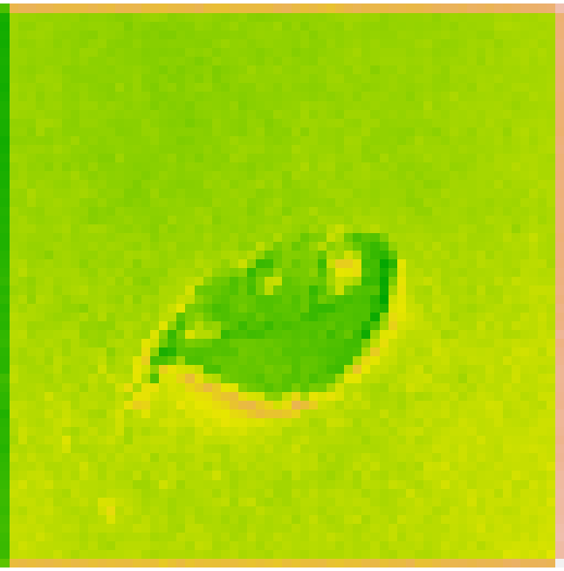

**Visualizing Activations with context**

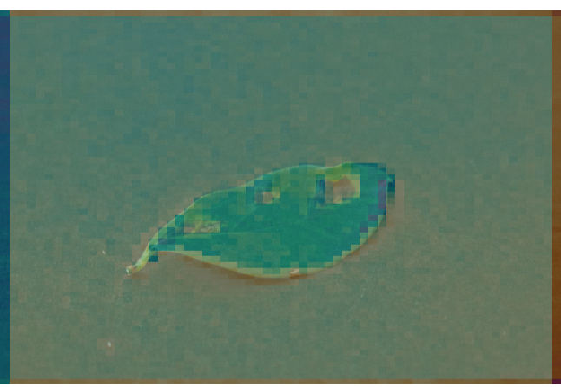

**Here, it’s interesting to note that the black spots on the diseased tree leaves are strongly activated. this is probably how the network can tell the difference disease and no disease.**

**Q3**

**3(a)**

**Model Overview**

* We utilized U-Net for the segmentation of neither (background), lung, or airway.
* Input: 128 x 128 x 1 input images (rescaled and greyscale).
  + Trained on 26*200 images (sampling 200 slices from each CT)
* 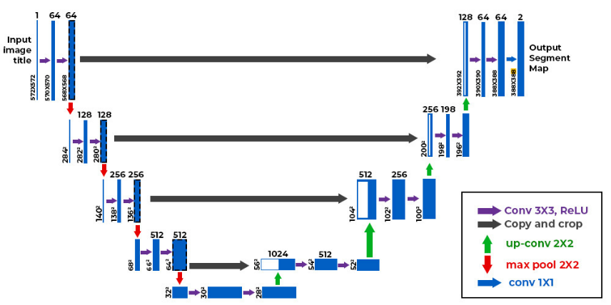Model: U-Net Architecture
* Settings:
  + Adam optimizer, learning rate = 0.001
  + Categorical cross-entropy with 3 categories (neither/lung/airway)
  + Accuracy metric
  + 10 epochs, 32 batch size

**Model Training Loss/Accuracy**

* Loss: 0.0345
* Accuracy: 0.9877

**Model Validation Loss/Accuracy**

* Loss: 0.0385
* Accuracy: 0.9862

**Model Test Loss/Accuracy (20% split)**

* Loss: 0.0369
* Accuracy: 0.9866

**3(b)**

**Image 27 Loss/Accuracy**

* Loss: 0.0495
* Accuracy: 0.9817

**Confusion Matrix**

|  |  |  |  |  |
| --- | --- | --- | --- | --- |
|  |  |  | Ground Truth |  |
|  |  | Neither | Lung | Airway |
|  | Neither | 2830427 | 46265 | 562 |
| Prediction | Lung | 10528 | 383138 | 3 |
|  | Airway | 1217 | 1469 | 3191 |

**Slices of the images:**

From left to right: x(data), neither(truth), lung(truth), airway(truth)

From left to right: neither(prediction), lung(prediction), airway(prediction)

Another image:

The U-Net model provided good results: high accuracy across training, validation, and test datasets. However, because of the imbalanceness of our data, classifying them as neither or lung achieves a high accuracy score. From the confusion matrix, we noticed that the prediction accuracy for the airway is not consistent with the overall 98% accuracy.

To address this issue and for future investigations, it would be nice to use alternative metrics, such as the multiclass-F1 score, and also put weights to minor categories (airway in our case) to provide more accurate results.